**Virtual Environments**

**Conducting a VE Experiment in HIVE**

December 2016

By

**Alexander C Whitehead**

Word Count: 1880

Table of Contents

1 Introduction 3

Null Hypothesis 3

Alternative Hypothesis 3

2 Methodology and Design 4

3 Results 7

4 Discussion 9

# Introduction

This is a report describing an experiment to be carried out to discover and then discuss the legitimacy of virtual reality technologies in creating realistic virtual environments.

The experiment to be carried out will involve the use of head mounted displays to create the illusion of reality via a virtual reality simulation.

The concept of the experiment is to test a person’s perception of reality while using a head mounted display and a conventional display and then to compare the difference between these results. This will be used to conclude if there is any advantage to virtual environments over conventional display methods when attempting to display realistic simulations of everyday situations.

To test for a participant’s perception of reality in this instance the experiment will use the metric of a participants driving skill in the form of errors committed while driving.

## Null Hypothesis

The use of head mounted displays to create realistic simulations of virtual environments has no effect on driving skill or perception of reality

## Alternative Hypothesis

The use of head mounted displays to create realistic simulations of virtual environments has a positive effect on driving skill or perception of reality

# Methodology and Design

The experiment will be a 2x design experiment, meaning that the independent variable has two distinct levels, these being; with the head mounted display and with the conventional display.

Participants will partake in both experimental conditions (this is referred to as a within-subject’s design) this should lead to a decrease in the error variance of the results. This is because the effect of individual differences should be negated as each participant takes part in all conditions. The number of total participants for a statistically valid result should also decrease.

Participants will be allocated to each initial condition randomly, meaning that half of the participants will start with one of the two conditions and the other half will start with the other before swapping.

Some confounding factors inherent to the independent variables chosen which cannot be controlled include; The fact that this will be some participants first experience with virtual environments, thus this will affect their performance.

Also, while wearing a head mounted display it is impossible for a participant to see their own body, this could cause a disconnect between the virtual reality simulation and true reality. This may also affect a participant’s performance because they cannot physically see the apparatus being used to perform the experiment. For example, letting go of the steering wheel while wearing the head mounted display and being unable to find it again.

The dependent variable will be the driver’s skill; this will be measured in this instance by the number of errors committed by each participant. This means that the dependent variable is being measured on a continuous, arbitrary, interval scale. This is because the total number of errors made has no intrinsic meaning and is used only as a measure to compare between participants and conditions. The driver’s skill is being used to infer any increase or decrease in perceptual awareness given by either condition.

To conduct the experiment certain apparatus will be required. For starters; a virtual reality simulation program will be needed and a computer with a quad buffered graphics card and adequate specifications will be required to render the virtual reality simulation at a high enough frame rate. A head mounted display will be required to display the simulation (in this case an Oculus Rift) This can be seen clearly in the pictures below (Figure 1) (Figure 2). A conventional display will also be required for the none simulated condition.

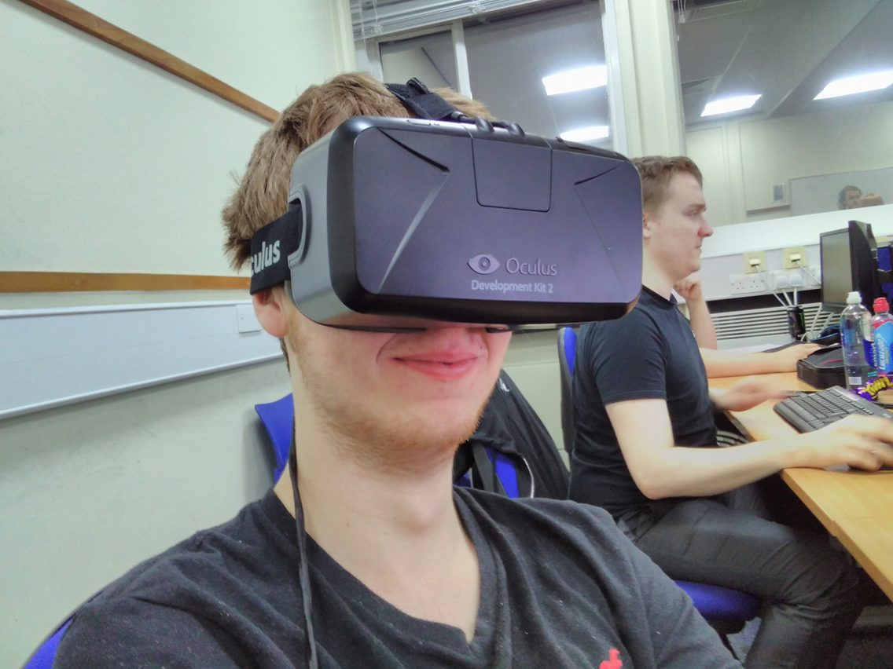

Figure 1: This picture shows a participant wearing a head mounted display.

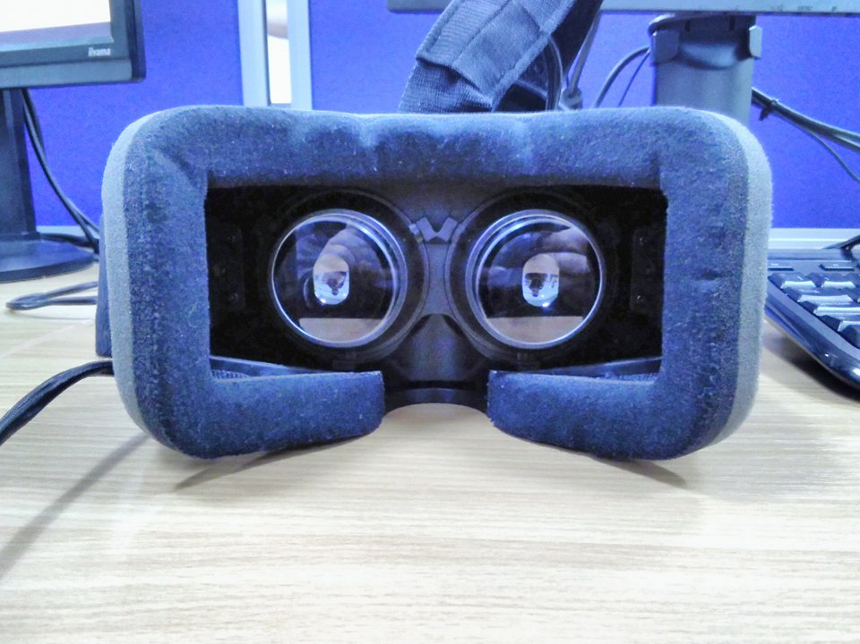

Figure 2: This picture shows a view of the inside of a head mounted display, here the lenses can be seen clearly.

To enhance immersion a driving seat with steering wheel will be used as an input device. These can clearly be seen in the photo below (Figure 3).

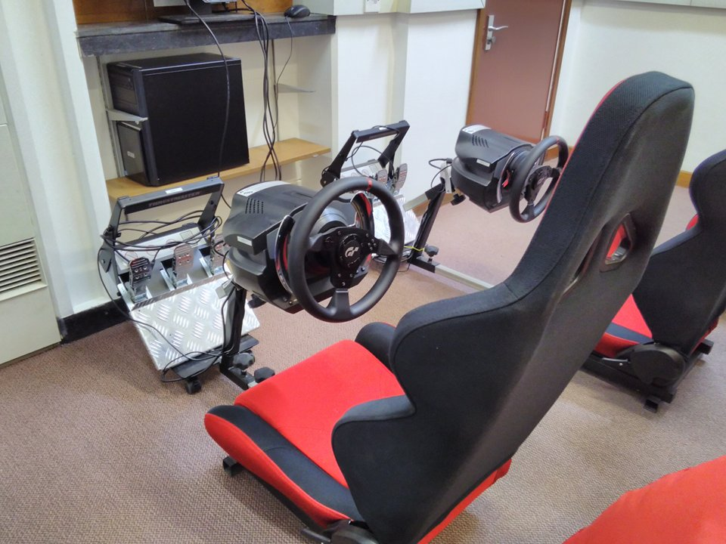

Figure 3: This picture shows the driving seat and steering wheel.

The program used in the experiment will be a simulation of a car driving down a straight road with barriers in its path. The car will need to be steered between the barriers with the steering wheel and every collision with a barrier will count as an error. The barriers will create gaps either to the left or right of the car and the order of the gaps will be randomly generated. If the car leaves the road or the car is turned through 180 degrees, the experiment will end and the results from that participant discarded. A realistic speed for the car and resistance from the steering wheel will be required to enhance immersion. The number of barriers and distance between them will be fine-tuned so that the experiment lasts a reasonable time while giving valid results. This will be assessed during a pilot study.

The procedure for the experiment should be performed uniformly, therefore a script should be produced to be followed by the experimenter, this should reduce error variance. There should be two scripts one for each order of conditions. These scripts should contain an area to record the participants score, their age, if they have any known visual defects and if they are experienced drivers. This will allow better discussion of results after the fact.

The script should also contain a bullet point set of instructions to be followed by the experimenter, including; an option to adjust the car cockpit to the participants liking and dimentions, uniform instructions on what to do when the experiment begins, instructions on how to record the data and instructions on how to perform a debrief after the experiment.

# Results

The participant pool for the experiment was selected from 3rd year computer science undergraduates at the University of Hull. From this pool, participants were selected upon the condition that they studied the virtual environments module. This was because these students were predisposed to having experience with virtual environments, meaning that there should be a lower level of error variance in the final results as participants are reacting to a difference in perception between virtual environments and reality rather than reacting in awe at the virtual environment.

This participant pool was also desirable as the experimenters were experimenting upon themselves and therefor would not require ethical approval, hence reducing the time it would take to acquire results.

Figure 4: This graph shows the results for all participants ordered with ascending HMD (head mounted display) results.

Figure 5: This graph shows the mean (average) of all participants results for both conditions. The error bars shown represent the standard deviation of the results.

The graph above shows the mean (average) of all participants results for both conditions. The error bars shown represent the standard deviation of the results. As can be seen from this graph (Figure 5) when an average is taken of all participants results there are more errors committed when a participant is using a screen rather than a head mounted display. This can be further reinforced by the fact that the standard deviation error bars used to represent the reliability of the results appear to be generally homogeneous as their magnitude is very similar. However, the results may not in fact be statistically significant because the standard deviation error bars overlap by more than 49%.

Figure 6: This graph shows the distribution of the frequency of the difference between the two conditions results for each participant.

The graph above shows the distribution of the frequency of the difference between the two condition’s results for each participant. As can be seen from this graph (Figure 6) the distribution follows a loose bell curve that is not skewed in either a positive or negative direction, plus the distribution gradually rises from one side and descends gradually on the other meaning that the distribution is neither leptokurtic or platykurtic. This means that the results are normally distributed.

A paired-samples t-test was conducted to compare errors committed in the head mounted display and the conventional display conditions. There was a significant difference in the scores for the head mounted display (mean = 9.5, standard deviation = 5.798444) and the conventional monitor (mean = 12.33333, standard deviation = 5.736773) conditions; t (41) = -2.91952, p = 0.005672

The results of the t-test can be believed to be reliable because all of the parametric assumptions have been met; the standard deviation error bars generally appear to be homogeneous and the distribution of the frequency of the difference between the two conditions results for each participant appears to be normally distributed. Thus even though the standard deviation error bars overlap by more than 49% it can be believed that the results from the experiment are statistically significant and no type 1 or type 2 errors have been committed.

# Discussion

As can be seen from the results of the t-test carried out in the results section of this report the p of this experiment is 0.005672, this is less than 0.05 meaning that there is less than a 5% chance that the results are affected by random chance or error (there is in fact a 0.5672% chance of the results being affected by random chance or error).

This means that there is a statistically significant difference between the errors committed during driving using a head mounted display and driving using a conventional display. Thus it can be inferred that a person’s perception of reality is enhanced when using a head mounted display over a conventional display device.

Furthermore because of the results given it is possible to reject the null hypothesis (The use of head mounted displays to create realistic simulations of virtual environments has no effect on driving skill or perception of reality) and accept the alternate hypothesis (The use of head mounted displays to create realistic simulations of virtual environments has a positive effect on driving skill or perception of reality) as being correct.

Even though a statistical significance has been found it cannot be said that the experiment conducted was perfect, if the experiment was to be conducted again certain elements would need to be changed. These include; when the experiment was conducted data was collected on whether a participant had a visual defect or not, unfortunately because instructions were unclear this section was filled in differently by each experimenter, in the future it would be sensible to replace this section with a simple tick box stating if the participant had any kind of visual defect at all.

Also, the participant pool was quite uniform and not representative of the wider general public, the average age of the participants was 23 and 17/42 of them had never driven before, for the next experiment it might be wise to attempt to acquire a more diverse participant pool for a more representative result.

In conclusion the results attained did prove what was set out to be proven. However, further experiments would be advisable taking into account the improvements listed above if more valid results are desired.